Hi Sunny –

Thanks so much for the modifications to the charts and the new horizontal bar graph. All looks good.

I was wondering if we can continue the chart development with the following items listed below. There are many features/requests listed, and I will do my best to describe each feature.

1 – Changing default color scheme:

I made some very slight changes to the red/blue/green/yellow color scheme. The modifications are small, but the purpose was to adjust the colors so that yellow would be a tad more noticeable. Can the colors of the charts (where appropriate) please be adjusted to the following:

Red: FF595E  
Yellow: FFCA3A  
Green: 8AC926  
Blue: 1982C4

2 – Main CSI chart

Adding quadrant to tooltip

The data in the historical CSI table contains values that represent the exact CSI quadrant for each date. I have shown a dataframe to depict this below:

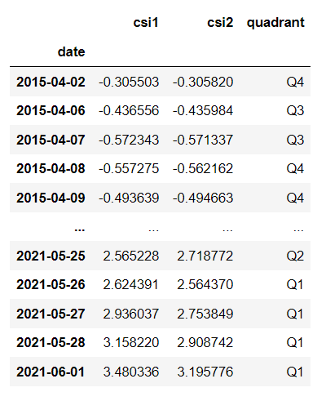

Right now, we are not using the quadrant column but I am hoping to be able to have this information appear in the tooltip. I believe in the pythonanywhere table, this column is an integer instead of a string. Nevertheless, is it possible for the tooltip to display “Quadrant 1” for days when this column is 1 (and “Quadrant 2”, “Quadrant 3”, or “Quadrant 4” when the value is either 2, 3, or 4)?

Annotations for CSI chart

I would like to add an “Annotations” function to the chart’s legend. However, when clicked, I’m hoping that the background color can be dynamically changed for the entire history of the chart. Do you recall a while ago (about a year ago) when we made the following chart using matplotlib in Jupyter?

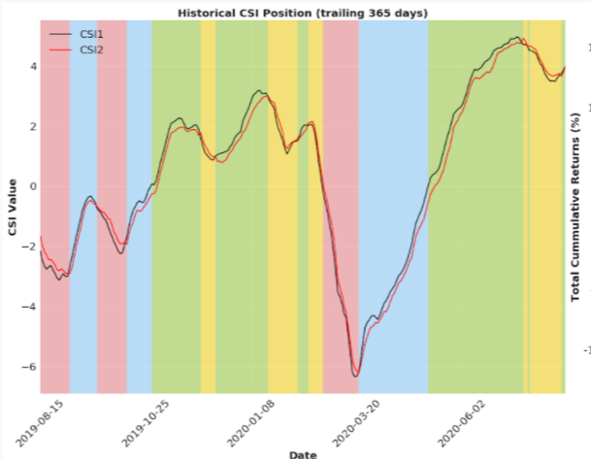

I’m hoping to be able accomplish the same here with our chart. Is it possible to add a background to the chart where the color will correspond to our color scheme (based on the CSI quadrant on the given day)? The only other thing I would ask here is that we use a lighter opacity than our original Jupyter example.

3 – Horizontal bar chart

I really like how the new horizontal bar chart turned out. I think it communicates the information really well. I wanted to ask if we can make the following enhancements to it:

1. Add an axis break to both the positive and negative sides of the chart. Amcharts demonstrates this via the following example:

<https://www.amcharts.com/demos/column-chart-with-axis-break/>

I was wondering if we can actually add this functionality twice to the chart (as indicated in the screenshot below):

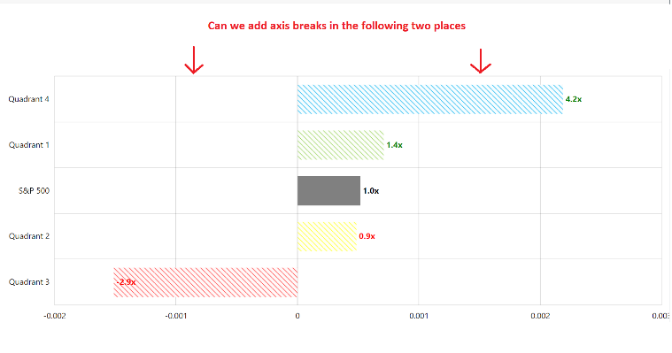

I admit this is very experimental. My goal is that by doing so, it will make the differences in values between Quadrant 1, S&P 500 and Quadrant 2 more noticeable.

I also saw that amcharts allows us to customize how large the gap is that comprises that axis break in the code below:



Since we will be using two axis breaks, can the number here be changed to .025 (instead of .05)? This way, the entirety of the axis break surface area will cumulatively take up the same amount of total space as the single axis break shown in their example.

1. Can the x-axis ticks be changed so that they instead read in the same format as the annotations (e.g., 1x, 1.2x, 1.4x, etc)? The tooltip value is ok as-is (the actual numerical value).
2. Is it possible to remove some of the padding on the left and right sides of the chart? I highlighted the areas in the screenshot below. I wouldn’t suggest we totally eliminate the blank area between the end of the most extreme bars and the axes, but I think it would be beneficial if some of the space could be eliminated. When viewed on a desktop browser, it doesn’t matter too much, but I think this will help the rendering when loading on a mobile device. 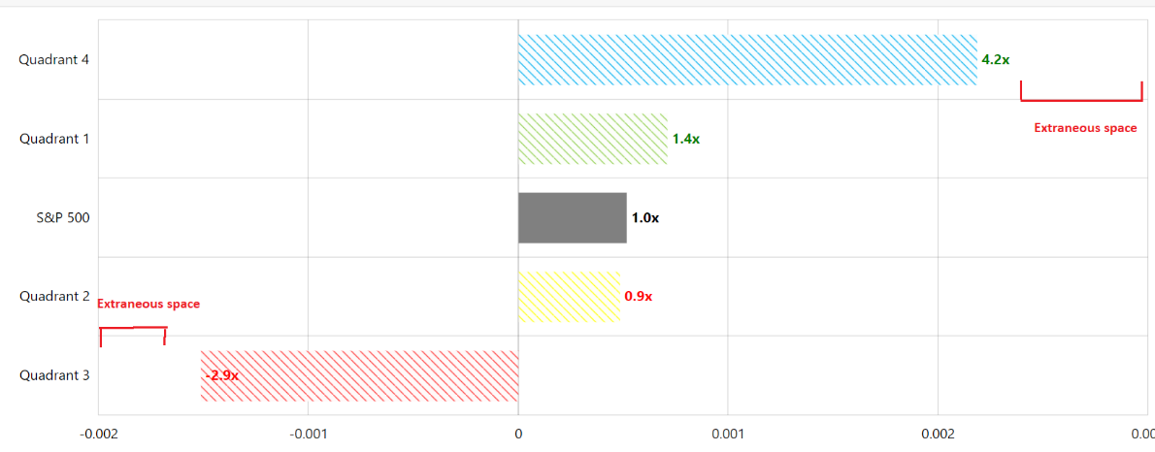
3. Can the dx offset value be inversed when its being applied to a bar with a negative value? (such as the below example)

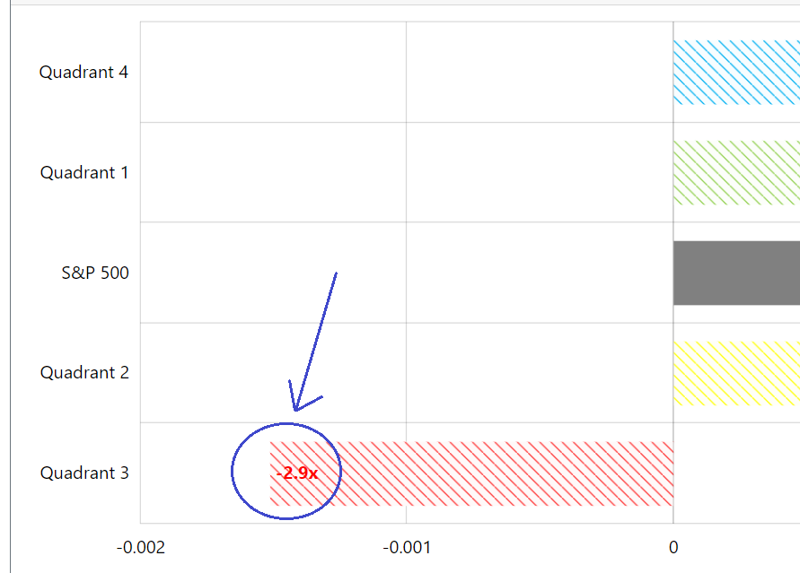

4 – fat tails chart

This one is easy… can we reduce the length of the line that corresponds to the annotations on this chart? Its ok on large monitors, but it begins to get skewed when viewed on smaller monitors or mobile. (please see screenshot below)

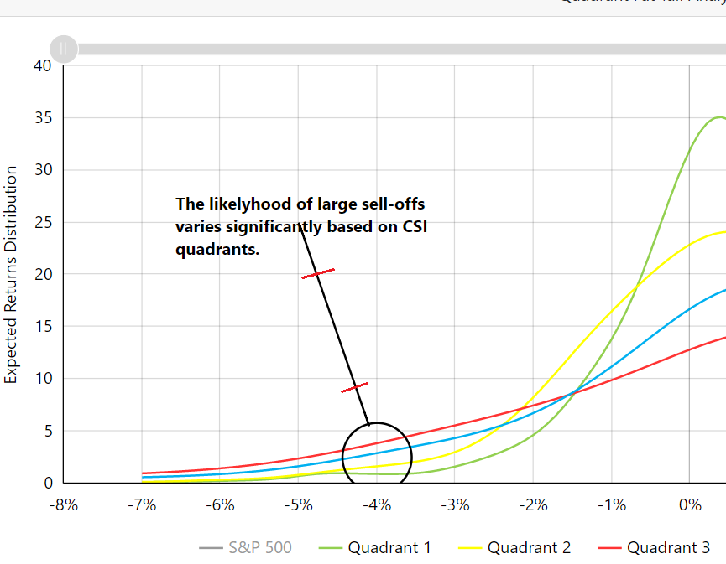

New chart #1 – Treemap

I would like to try and make a treemap chart just like the existing amcharts example here:

<https://www.amcharts.com/demos/multilevel-tree-map/>

This chart will be an experiment, so I have not created a database table containing the information. The treemap is a chart that contains two layers of information. The first layer of information already exists in a table on pythonanywhere that we’re using on a different chart, and then the second layer of information is contained in the CSV files I have sent over.

The first layer of information is the percentage of historical time that CSI has been in each quadrant. These are the percents currently used in the *Quadrants Historical Performance Chart*. These percents will dictate the overall size of each square.

The second layer of information will be used to generate the five secondary squares within each primary square. The names of each of the secondary squares will be:

* S&P 500
* Russell 2000
* Oil
* NASDAQ 100
* 20+ yr Treasuries

The size of each of the secondary squares will be determined by the percentage in each CSV. You will see that many times, the values are negative. Negative values are not able to be graphed by a Treemap chart. For this reason, lets use the abs() value of each number in the CSV files to determine the size of each secondary square. However, lets try and have the actual value (whether positive or negative) shown in the tooltip.

Speaking of the tooltip, would it be possible to have the tooltip show each number as a traditional percentage (e.g., .452 would be presented as 45.2%)?

I have also included transparent images that can serve as the background image in each primary square just like how the amcharts examples uses the symbol of each major automotive manufacturer.

New Chart #2 – Bubble Based Heatmap

The second new chart I’m hoping to create is the bubble based heatmap similar to the example on amcharts site: <https://www.amcharts.com/demos/bubble-based-heat-map/>

The goal of the chart will be to graph the distribution of daily returns of each quadrant. The output will hopefully look something like this:

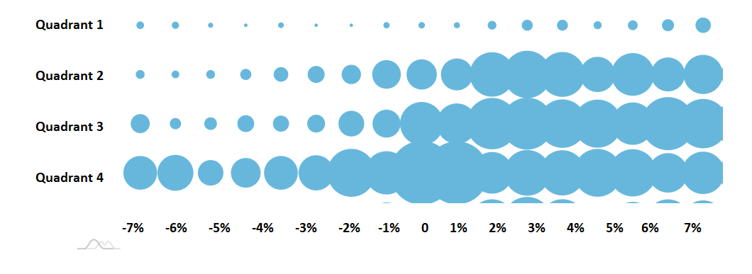

It may end up looking a little different… but the above mock-up made in MS Paint I think demonstrates the direction I am trying to take with the chart in general.

I have included the information for this chart in a CSV to make things a tad easier since the chart is an experiment for now.